Patient Participation DES - Local Participation Report
March 2014

Author and Role: | Dr Richard Tatham, GP
Organisation: | Springbank Health
Document Reference: | PPG report 2013-14
Date Published: | 26th March 2014
Next Review Due: | 31st March 2015

Springbank Health Local Patient Participation Report - 26th March 2014
A description of the profile of the members of the PPG:

There are 12 patients on the patient participation group presently.

There are 6 male members and 6 female members.
The ages of patient members range from 16 to 82.

1 member is in the age range 0-18
9 members are in the age range 19-65
1 member is in the age range 66-75
1 member is in the age range 76+

All members are of white British ethnicity.
Members of the group represent those accessing our chronic disease services, contraception services and learning disability services.
The group is representative of the demographics of the patient population.

Meetings are also attended by 1-2 doctors, the practice manager and another member of practice staff.

Patient population profile
Age range | Male | Female | Total
0-18 | 641 | 541 | 1182
19-65 | 1734 | 1725 | 3459
66-75 | 307 | 292 | 599
76+ | 155 | 235 | 390
Total | 2837 | 2793 | 5630

A description of what steps the practice has taken to ensure that the PPG is representative of its registered patients:
Posters in surgery waiting room on a patient participation group board at both Green Hammerton and Tockwith surgeries.
Patient group article in the newsletter distributed to over 2500 homes in the area.
Leaflet advertising the patient group available in surgeries and also delivered to homes in the area.
Information on the website.
Part of the annual survey was about the patient participation group.
Doctors actively promoted the patient group whilst in consultations.

How we agreed on a local practice survey and how we did the survey

This year, the patient group coordinated a survey which was based on issues raised in last year’s survey.

Issues highlighted last year included lack of knowledge about opening hours, with 80% of respondents unaware of our extended opening hours. Similarly, only 17% of respondents had registered to book appointments online.

As a patient group, we discussed the issues that were highlighted last year and how our action plan to inform patients about practice services may have made a difference.

The survey this year was based on similar themes to check our success and where we needed to focus more.

It was decided that the survey would gain the most respondents with simple yes/no answers, in a format that would take no more than a couple of minutes to complete, allowing patients to do so in the waiting room. However, we also left an area on the survey form where we encouraged patients to write more freely about the comments. We hoped that this would stimulate further discussion amongst ourselves with respect to areas we should focus on in the coming year.

Therefore, the survey was conducted by offering survey forms to patients in the waiting room who volunteered that they were happy to complete one.

Also, the survey was designed to maintain the anonymity of respondents.

How we discussed the survey results and formulated an action plan

The survey results were discussed amongst group members over 2 meetings. The first was on 30/1/14 and the second was on 6/3/14. At these meetings, we discussed the survey findings and also drew up an action plan based on the survey. Thus, the action plan was formulated through discussion amongst group members.

The survey results are shown on the following 2 pages
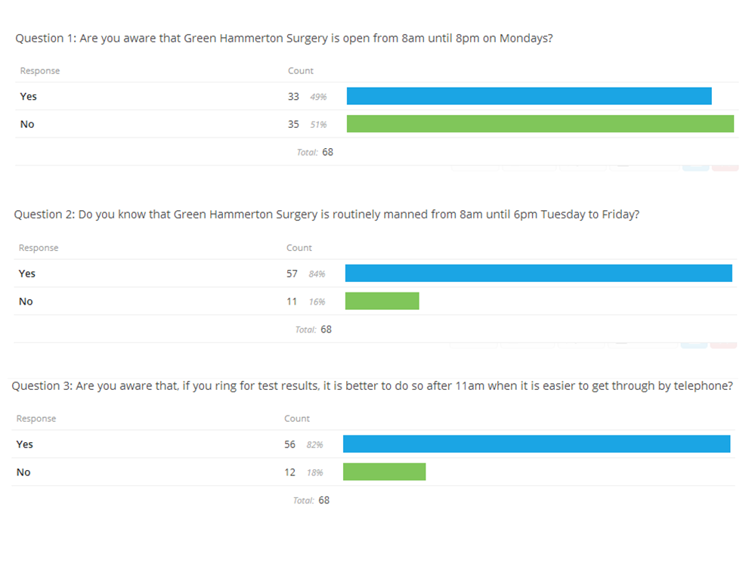

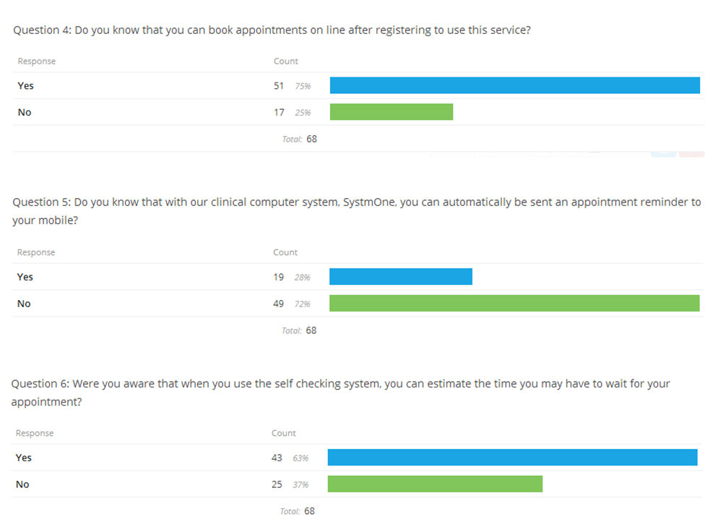

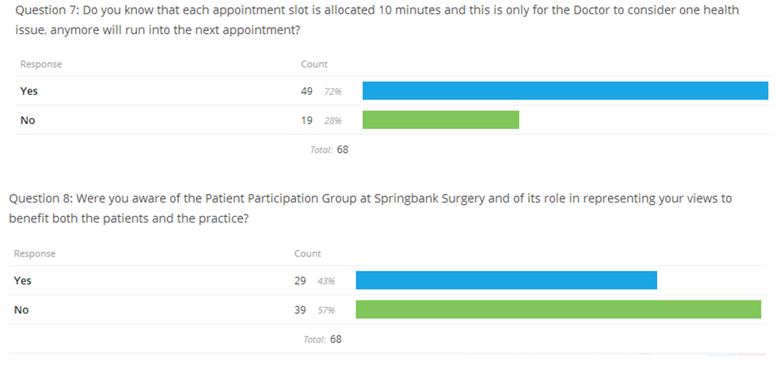

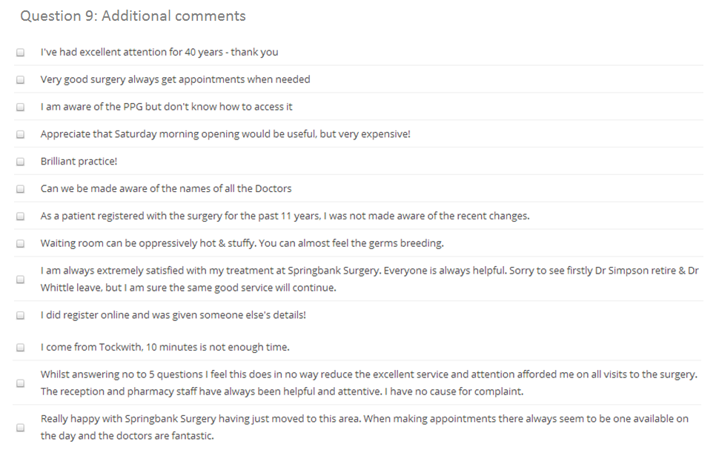

Survey findings and action plan

Last year’s survey showed that 80% of respondents were unaware that we were open until 8pm on a Monday. This year’s survey suggested a figure of 51%. This shows some significant improvement but we feel we could still advertise this service better. However, there were good levels of knowledge regarding our core opening hours. Similarly, 82% of respondents already knew it was preferable to call after 11am for blood results. 75% of patients knew they could book appointments online, again an improvement on last year. However, we still had few respondents who knew that they could opt to be contacted via text message regarding appointments. Finally, in that 57% of respondents were still not fully aware of the patient group, we saw that this needed to form part of our action plan.
We were pleased to see positive comments left, with one patient volunteering that still felt they received and excellent service despite themselves answering ‘no’ to several of the questions.
The action plan following the survey was discussed during consecutive patient group meetings, first on 30/1/14 and then on 6/3/14.
The main points from the action plan were to increase patient understanding of the patient group, advertising this in more depth and more widely. We were also keen to advertise our extended opening hours.
We decided that new monitors in the waiting rooms could be used to disseminate information to patients in the waiting room, specifically scrolling through pages related to topics such as opening hours, patient group, text messages and email and any other items which arise.
Furthermore, we decided that we would continue with the newsletter format which had received positive feedback from the winter and will start writing the spring edition immediately.
The patient group is to be advertised on the waiting room boards continuously and we will update these so as to keep them fresh and interesting. The patient group has its own flyer which was only just in production at the time of the survey and the distribution of this flyer will continue, with the aim of improving wider knowledge regarding the purpose of the patient group.
Finally, we will continue to solicit the feedback of patients in order to help monitor our progress. We will do this by using feedback forms which are available at reception. This process already started. For example, some patients used these feedback sheets to suggest we enable payments by credit and debit card. This has now been done for both surgeries. Also, a patient pointed out some potholes in the carpark and these were filled promptly. We are offering a pre-ordering service for repeat prescriptions, whereby patients are able to request items one month in advance. Finally, the feedback that our telephone system required upgrading has also already been actioned. We are grateful for the positive feedback we have already received for making these changes. Thus, we are continually soliciting feedback and acting on it promptly in addition to the more formal survey described above.

Our opening hours and how to obtain access

The practice is open at the following times:
Monday 8am-8pm
Tuesday-Friday 8am-6pm
Tockwith branch is closed on a Thursday afternoon
Appointments can be made by calling us on 01423 330030. They can also be made online once you have registered for a password to enable this.
We are always accepting new patient registrations
Our appointments are split between pre-bookable appointments and appointments which can be booked on the day, usually reserved for more urgent matters.
Our extended opening hours are on Monday evenings. These are all pre-bookable appointments.
Appointments can be made with a GP, practice nurse, healthcare assistant, midwife or health visitor. Our staff run clinics in health promotion, asthma, COPD, heart disease, diabetes and other chronic disease reviews. We also host clinics for diabetic eye screening, chiropody and warfarin testing.

